**CSS Layout- Lab 07**

Vrij Sheth - 201742651

Department Of Mathematics and Computing , Mount Royal University

Comp 2511 - 003 ; Web I: Client Development

Jim Davis

March 11, 2024

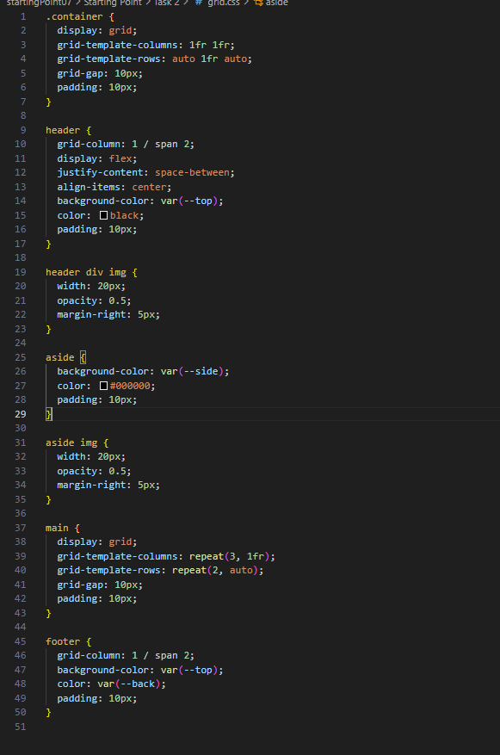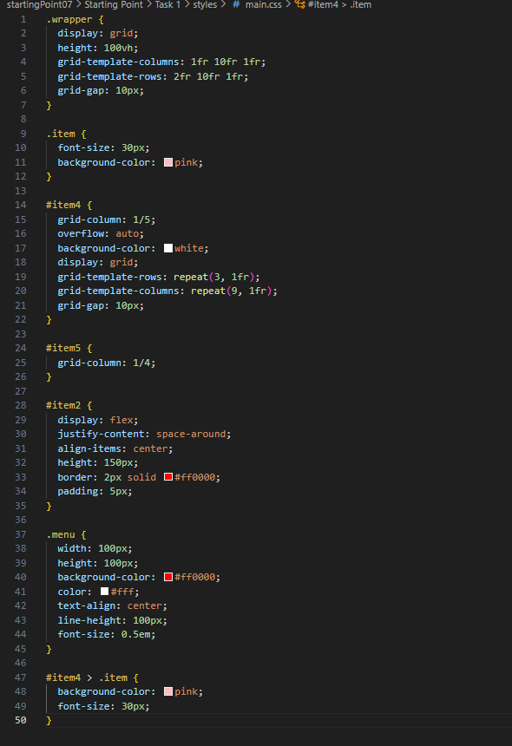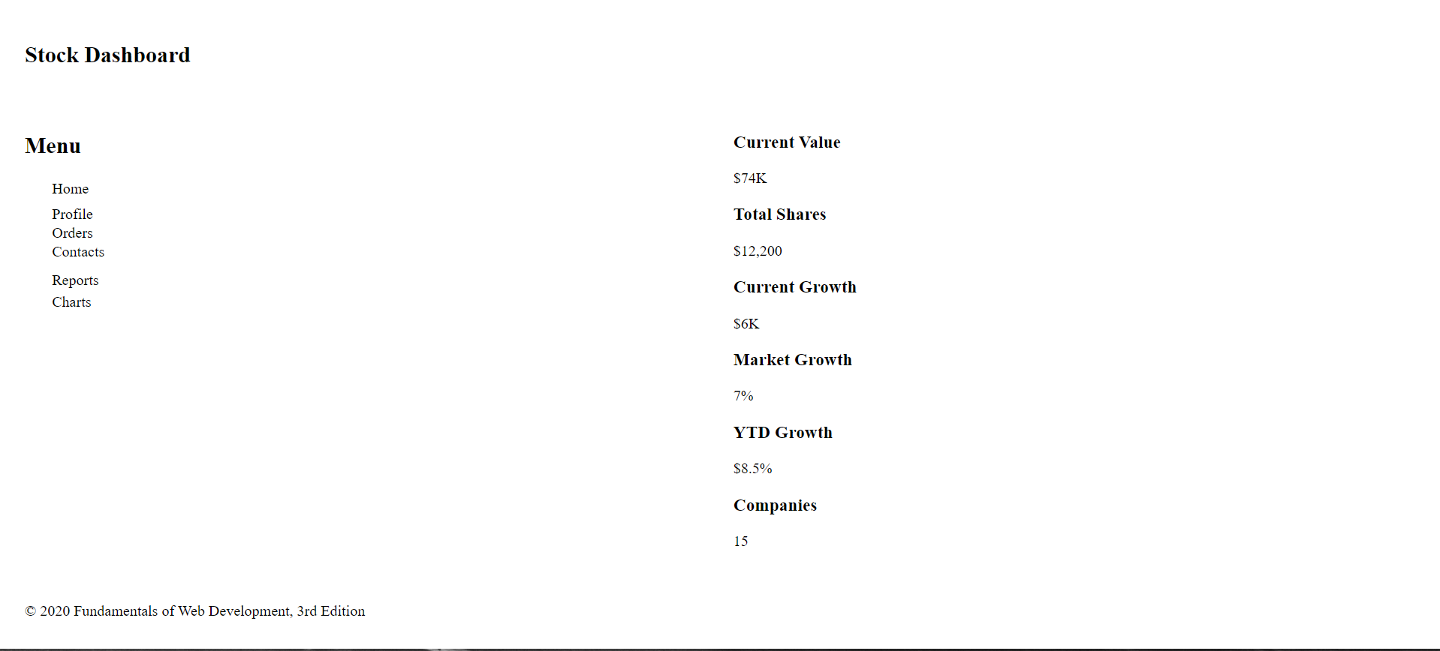

I preferred to use the CSS flexbox as it was the most simple to understand.